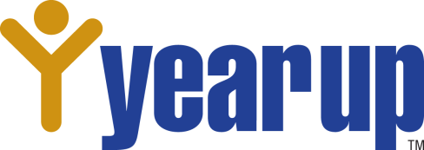

**Career and Education Plan**



|  |  |  |  |  |  |
| --- | --- | --- | --- | --- | --- |
| **Start of L&D**  **At Year Up** |  | **Year Up Goals** | **Graduation Goals** |  | **Later**  **Career Goals** |

**Fill out the below boxes with big picture goals/dreams for your future:**

|  |  |  |  |
| --- | --- | --- | --- |
| **Environment** | **Year Up Goals**  **(Now to YU Graduation)** | **Graduation Goals**  **(Graduation to 1 year after)** | **Long Term Career Goals**  **(2 to 10 years after graduation)** |
| **Work** | What will you accomplish and learn in your YU classes and at internship?  I will develop my coding knowledge in HTML, CSS, JavaScript and Python. And learn new coding languages. I work to toward being professional. | What is your employment plan / goal for the first year after the program?  After I graduate YU I would like to start working as an entry level Data Analyst. | What are the job titles or career path that you plan to take for work?  For the next 2-10 years I want to be pro in my field and work in my dream companies Google or Microsoft. |
| **Education**  **(Degree Programs)** | * Earn 44 credits through Seattle Central College courses * Complete Certificate in Software Testing and Support | Do you plan to continue taking college courses? Earn an AA? Finish a Bachelors?  After YU I’m planning to earn my bachelor’s degree online after I find a sustainable job. | Do you need a degree for your career goals? Do you need an AA, Bachelor’s or Master degree?  Yes I would say Bachelor but not right away. |
| **Professional Training/**  **Certifications** | What certifications or online free courses do you want to complete during your time in the Year Up program?  I want to take Advanced Excel Certification. | What certification and/or additional job skills training will be needed for the job you want when you graduate?  SQL  Java  Advanced Python | What certificates and additional job skills will you need training on for your long-term career goals?  Full Stack develpoment |
| **Additional Info** | Anything else you want to work on or learn? Other goals to further your skills training?  I want to develop good communication skill. | What other plans and goals will support your dreams for the first year after you graduate?  To be more skilled and grow toward my goal. | What other goals will support your long term career plan?  Finishing my degree and develop my career. |

**Your Plan Details** (Please list details for your Career and Education Goals below):

**A. Certificates** I want to earn in the next 1 to 5 years: (include the name and the date you will complete it by)

* **Advanced Python-2025**
* **Advanced Excel-2024**
* **Java-2026**

**B. LinkedIn Learning, Coursera, or Other online training** I want to complete:

* **Python by Udemy**
* **Data Analysis by Coursera**
* **SQL by W3 schools**

**C. Colleges or other training pathways I’m considering:**

* **AA from Seattle Central**
* **BAS from University of Washington**
* **Other college training.**